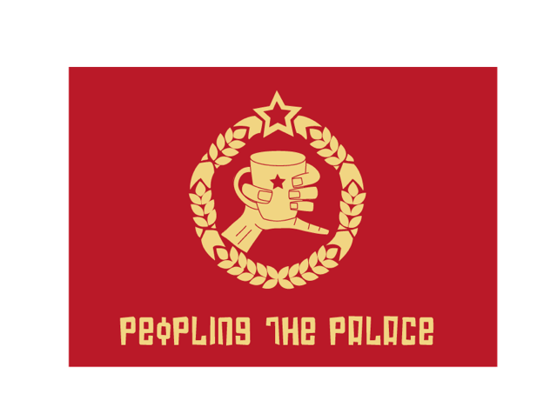
17-24 February 2013

Peoples Palace
Queen Mary University of London
Mile End Road London E1 4NS

Contact: Rose Sharp 020 7882 2851
r.sharp@qmul.ac.uk

Peopling the Palace

A week-long festival of performance, conversation and entertainment
that marks the launch of a new arts venue on an historic site in East London

The People’s Palace at Queen Mary University of London will host eight days of theatre, dance, performance and conversation exploring questions of work and leisure, wage and age in contemporary life. Who works, who can’t work, who has to work and who gets paid? What kind of art and entertainment can we enjoy when we are not at work, and who pays for that?

The festival includes work by two major British experimental theatre-makers – Geraldine Pilgrim (Handbag) and Simon Vincenzi (Luxuriant), as well as the first UK performances by the Canadian duo 2boys.tv.

It also involves a packed schedule of short shows, films and conversations in which artists of different generations work together and reflect on how they make a life by working on their art. Featured artists include Julia Bardsley, Bette Bourne, Hester Chillingworth, Tim Etchells, and Lauren Barri Holstein.

Artistic Director Lois Weaver: “We want the People’s Palace to be a focus for new work, and for new thinking about work and art. We also want it to be a social hub, a place where people can come and talk and make things happen together. This is what we mean by a twenty-first take on the original ethos of the People’s Palace.’

Other events will include participatory dance, post-work conversations about work with a range of artists and thinkers, film screenings and installations.

All of the events will take place in the newly refurbished People’s Palace at Queen Mary University of London, once a building dedicated to education and recreation for the working people of East London. Now restored as a venue for art and activism.

17-24 February 2013

For full program: www.airproject.qmul.ac.uk

